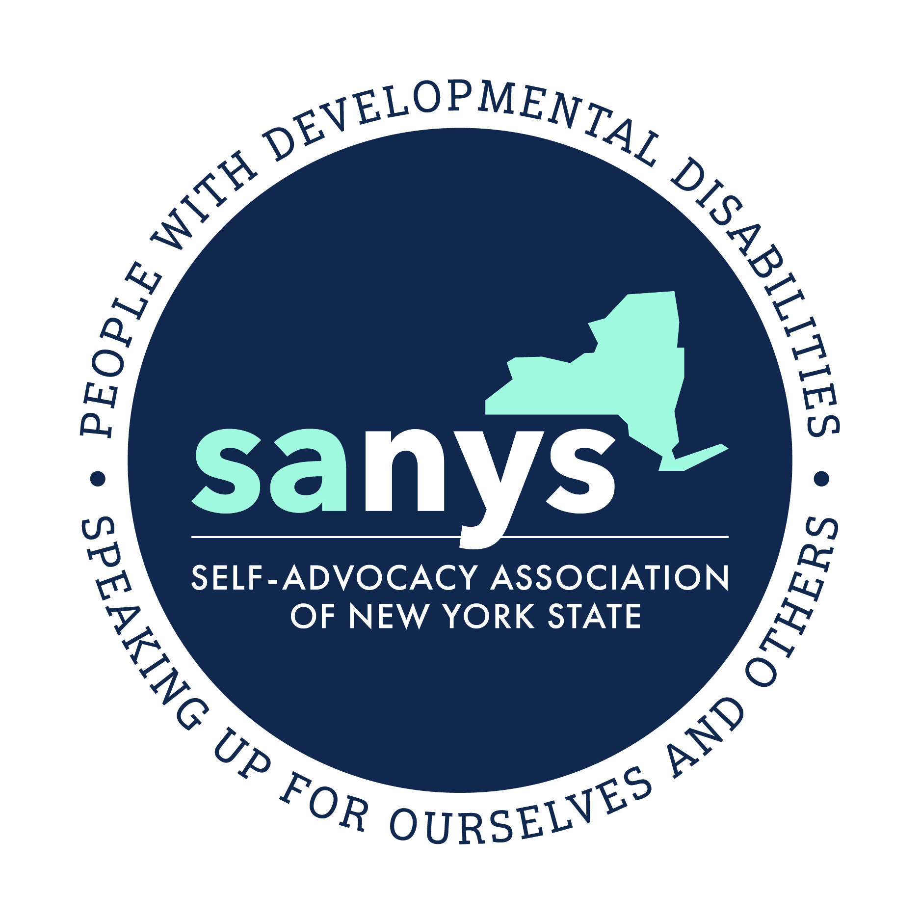

***The Self-Advocacy Association of New York State***

***Invites you to participate in our***

***Annual State Conference!***

**“Self-Advocacy: Stepping Up, Never Stepping Back”**

**Thursday – Saturday**

**October 10th, 11th, and 12th, 2019**

**Albany Marriott**

**189 Wolf Rd., Albany, NY**

***All conference registrations and payments due by August 31, 2019***

|  |  |
| --- | --- |
| **SANYS**  **500 Balltown Road**  **Building 12B**  **Schenectady, NY 12304** | **(518) 382-1454**  **Fax: (518) 382-1594**  **E-Mail: conf18@sanys.org** |
|  | |

|  |
| --- |
|  |

**CONFERENCE AGENDA:**

**Thursday, October 10th:**

Registration 1:00 pm – 6:00 pm

Mini Sessions 2:00 pm – 5:45 pm

Dinner & Awards 6:00 pm – 8:00 pm

Board Member Bingo 8:00 pm – 8:30 pm

DJ Dance Party 8:30 pm – 11:30 pm

**Friday, October 11th:**

Registration 9:00 am – 1:00 pm

Annual Members Meeting 8:30 am – 9:30 am

Commissioner’s Panel 10:30 am – 11:00 am

Lunch & Awards 11:30 pm – 1:00 pm

Workshops Session I 2:00 pm – 3:00 pm

Workshop Session II 3:15 pm – 4:15 pm

Workshop Session III 4:30 pm – 5:30pm

Banquet 6:30 pm – 8:00 pm

Movie: *Intelligent Lives* 9:00 pm – 10:30 pm

Dance Party 9:00 pm- Midnight

**Saturday, October 12th:**

Breakfast 7:30 am – 9:00 am

Closing Ceremonies 9:00 am -10:30 am

“Golden Key” Award to Marriott Staff



**CONFERENCE HIGHLIGHTS**

**Our theme this year is:**

**Self-Advocacy: Stepping Up, Never Stepping Back**

This year’s conference theme is about looking ahead and making a better future through self-advocacy. Self-Advocates have been speaking truth to power for decades and have worked hard to make better opportunities for themselves and others. However, we should never forget that we still have a long way to go. By “Speaking up for ourselves and others” we can keep the self-advocacy movement going forward.

**Mini Sessions:** Thursday afternoon we will have mini sessions involving movement, music, meditation, games, and speak outs.

**Friday Morning Annual Members Meeting/Breakfast:**  In place of the regional breakfasts, we will all be coming together this year to hear from our board of directors and administration. As always, we want to hear from you, so members of the board of directors will take questions and comments toward the end of breakfast.

***________***

**Entertainment**

**Thursday - DJ & Dancing**

**Friday –Dance Theme: Star Wars**

**Maybe you’ll win the COSTUME PRIZE!**

**SATURDAY MORNING EVENTS**

**Group Breakfast & Closing Ceremonies:**

We will eat breakfast all together with a program that includes speakers, music, and handing out the Golden Key to a Marriott staff person who has gone above and beyond. We will rally together, energized with a message to carry back home with us.

**WORKSHOPS & FOCUS GROUPS**

We will have a wide variety of workshops and focus groups that will provide us with great opportunities for learning and networking. **Here is a partial list of poetential topics, mini sessions, workshops and focus groups we are planning:**

* Commissioner’s Forum
* Songs of Self-Advocacy
* Care Coordination
* Diversity in the Self-Advocacy Movement
* Transportation Advocacy
* Arts and Advocacy Performance
* Autism and Self-Advocacy
* Supported Decision Making
* OPWDD Transformation
* Bullying Prevention
* Partners in Policymaking
* LGBTQIA
* Leadership Training
* Health and Well-being

**We have lots more activities planned. Watch the SANYS web site for updates – www.sanys.org.**

**AWARD NOMINATIONS**

Let us know which self-advocate, group, advisor, direct support professional, or organization you think is the most deserving of an award. **Please take some time to fill out and send in the awards nomination form on pages 11 & 12.**

**REGISTRATION INFORMATION**

**Hotel Accommodations**

**You will make your own room reservations and payments directly with the hotel.**

**The conference will be held at the Albany Marriott, 189 Wolf Rd., Albany, NY**

**Conference room rates are as follows:**

$136 per room, per night. Up to four guests can share a room and the costs. If you would like a cot in the room, there is an additional charge of $25 per cot per night.

***In order to receive these special room rates, be sure to tell the Marriott that you are attending the Self-Advocacy Conference.*** These rates do not include tax. If you are sponsored by an agency, be sure the Marriott has a tax-exempt form from your organization.

**ACCESSIBLE ROOMS**

**Availability of Accessible Rooms Is Very Limited**

The Marriott has several accessible rooms. Please see the following descriptions for room selection:

**Room Type 1:**

Accessible room with roll in shower (the shower will accommodate a wheelchair or roll in shower chair): They have 4 of this type. Located on 4 floors.

**Room Type 2:**

Accessible Room with low threshold shower entry (the shower in this room will not accommodate a wheelchair or roll in shower chair, but is more accessible than standard showers): There are 15 rooms of this type, with low shower entry, extra grab bars.

**Room Type 3:**

Standard Room:  They have 340 rooms of this type. Each has sliding glass doors, with a 4-inch step over to get in the shower and no extra grab bars. Can easily accommodate shower chairs for those who require them.

*The Marriott has doubles and kings for partially accessible and standard rooms. The fully accessible rooms are all king beds with sofa sleepers. Each wheel in shower room connects to either a king or a double standard room.

**If You Need an Accessible Room:**

**Call and request a room at the Marriott and they will be happy to assist you.**

**Marriott Hotel (518) 458-8444**

**If the Marriott no longer has a room available, please refer to the “Hotel Contacts” list.**

**HOTEL CONTACTS**

**Other Hotels:**

|  |  |
| --- | --- |
| **Best Western**  **Wolf Road** | **(518) 458-1000** |
| **Holiday Inn**  **Wolf Road** | **(518) 458-7264** |
| **Hampton Inn**  **Wolf Road** | **(518) 438-2822** |
| **Holiday Inn**  **Western Avenue** | **(518) 438-0001** |
| **Homewood Suites**  **Wolf Road** | **(518) 438-4300** |

**Please make sure you send in your registration for the conference as well as making your hotel reservation. These are two separate processes. If you have a hotel room and are not registered for the conference, you will not be able to attend.**

**LOCAL TRANSPORTATION:**

**Paratransit Requests (STAR):**

For paratransit from the train or bus station or to get around while you are here in Albany, take the following steps:

1. Contact your local paratransit company a month or so before the conference
2. Tell them you will be attending conference in Albany
3. Give them the dates
4. They will contact CDTA with your information
5. Contact CDTA 518-437-8378 to verify that they received your information
6. To make your reservation call CDTA 518-482-2022, press 3. It is best to do this **one week before the conference, but at minimum 48 hours prior**
7. Changes/Cancellations should be made at least 24 hours in advance by calling 518-482-2022
8. Please make sure you contact CDTA if you are not going to be taking your trips
9. If you are riding with a guest they ride for free. **If you are not enrolled in paratransit, you may be able to ride as a guest of another conference attendee.**
10. Your trip is $2.50 each way.

If you have any questions or concerns about this process you can call Shameka Andrews at 518-382-1454.

**Public bus:** A single ride will cost $1.50 and is the cheapest option to get around Albany. Use their Trip Planner to find the best route to your destination at **tripplanner.cdta.org** or download the CDTA iRide app on your smartphone. You can also call **518-482-8822** and a customer service representative will help you find your route.

**Taxis:** This is the most expensive option. Accessible taxis are available but limited in number, so they should be requested in advance.

Capitaland Taxi: 518-453-8888 Capital City Taxi: 518-478-6994

***________***

|  |
| --- |
|  |

**REGISTRATION**

As attendance for our State Conference has grown, we have had to limit the number of registration options to either the Full Conference or All Day Friday. This will allow us to provide a more meaningful conference experience for as many guests as practical.

**FULL** **CONFERENCE: $185.00**

Enjoy the whole conference experience of learning and networking, good food, and fun. This includes registration for all conference activities and meals for the three days.

**ALL DAY FRIDAY $125.00**

Workshops & Focus Groups, Lunch and Evening Banquet

**REGISTER NOW!**

**SPACE IS LIMITED!**

**PAYMENT POLICY**

**The popularity of our State Conference has continued to grown and we must ask that everyone register and pay before the Conference so that we can accommodate the large number of attendees.**

**THERE WILL BE NO ONLINE REGISTRATION THIS YEAR SO PLEASE BE SURE TO SEND YOUR PAYMENT IN WITH YOUR CHECK OR MONEY ORDER.**

**WE WILL ONLY BE ABLE TO REGISTER YOU WHEN WE RECEIVE YOUR REGISTRATION FORMS AND PAYMENT TOGETHER.**

**WE MUST RECEIVE YOUR PAYMENT ALONG WITH YOUR REGISTRATION FORM BY 8/31/19, FOR YOU TO BE REGISTERED FOR THE CONFERENCE.**

**NO REGISTRATIONS WILL BE ACCEPTED AT THE CONFERENCE.**

***EVERYONE, INCLUDING SUPPORT PEOPLE MUST BE PRE-REGISTERED AND PREPAID***

***THANK YOU FOR YOUR COOPERATION!***

**Conference registration forms including payment may be mailed to:**

**Self-Advocacy Association of NYS, Inc.**

**500 Balltown Rd, Bldg. 12B**

**Schenectady, NY 12304**

**Make your check or money order payable to “SANYS”.**

**CANCELLATION POLICY**

If you need to cancel this registration, please e-mail [CONF19@sanys.org](mailto:CONF19@sanys.org) or call our office at (518) 382-1454. You will receive a full refund if you cancel by August 31, 2019. For Cancelations 30 days prior to the conference (September 4, 2019) a 50% refund will be given. For cancelations less than 30 days prior to the conference no refund will be given.

**GROUP REGISTRATION AND PAYMENT**

**If you are from a provider agency and are registering a group of people**, We ask that you use the group registration form (download group registration form from our website) and please mail your form along with payment to:

**Self-Advocacy Association of NYS, Inc.**

**500 Balltown Rd, Bldg. 12B**

**Schenectady, NY 12304**

* IF YOU DO NOT YET KNOW WHICH SUPPORT STAFF WILL BE COMING, PLEASE INDICATE "STAFF" FOR FIRST NAME & “AGENCY “FOR LAST NAME (for example: Staff - Arc of Orange County). For additional staff, just put “staff 2 as first name and agency name for last name (for example: Staff 2 – Arc of Orange County). **Please call 518-382-1454 with the staff name at least one week before the conference.**

**QUESTIONS?**

**If you have any questions or need help, please send an e-mail to:** [**conf19@sanys.org**](mailto:conf19@sanys.org)

**or call our office at (518) 382-1454.**

|  |  |  |  |  |  |  |
| --- | --- | --- | --- | --- | --- | --- |
| **SANYS STATE CONFERENCE REGISTRATION FORM** | | | | | | |
| **Mr.**  **Ms.**  (please circle) | **First**  **Name** |  | | | **Last**  **Name** |  |
|  | | | | | | |
| **Mailing Address** | | Street/PO box: City: Zip: | | | | |
| **Who should we contact with questions about this registration?** | | | Name: Phone: e-mail | | | |
| **Contact Email Address:** | |  | | | | |
| **Contact Phone:** | |  | | | | |
|  | | **BILLING INFORMATION**  **\*Please fill out if someone else is paying for you. Please include the name of the company if a provider organization is paying.** | | | | |
| **\*Billing Contact** | | First Name: Last Name: Title: | | | | |
| **Company:** | |  | | | | |
| **Billing Address:** | | Street/PO box: City: Zip: | | | | |
| **Billing E-mail:** | |  | | | | |
| **Billing Phone:** | |  | | | | |
| **Billing Fax:** | |  | | | | |
|  | | | | | | |
| **What is your SANYS Region?**  Regions are listed below with the name of their Regional Coordinators.  **(circle one)** | | |  |  |  |  | | --- | --- | --- | --- | | **NYC**  Sandy Mislow | **Long Island**  Bridget Cariello | **Lower Hudson Valley**  Cynthia Gilchrist | **Capital District/**  **Upper Hudson**  Cynthia Gilchrist | | **Central**  Dan Flanigan | **Western/Buffalo**  Sophia Roberts | **Western/Finger Lakes**  Sue O’Hearn | **I DON’T KNOW** | | | | | |
| **Please circle the category that best describes you** | | |  |  |  | | --- | --- | --- | | **Self-Advocate** | **Family Member** | **Provider Agency** | | **Association Staff** | **OPWDD** | **SANYS Employee or SANYS Board Member** | | **Other** | | | | | | | |
| **If you receive supports from an agency or are employed by an agency, please list it here. You can also list your Self Advocacy Group affiliation.** | | | |  | | |

|  |  |  |  |  |
| --- | --- | --- | --- | --- |
| **PLEASE SELECT YOUR CONFERENCE OPTION & RETURN IT TO US WITH REGISTRATION FORMS (Pages 9 - 10) AND YOUR PAYMENT (CHECK, MONEY ORDER) BY AUGUST 31, 2019.** | | | | |
| **☐ FULL CONFERENCE:**  Enjoy the whole conference experience of learning and networking, good food and fun. This includes registration for all conference activities and meals for the three days. | | | | **$185.00** |
| **☐ ALL DAY FRIDAY**  (LUNCH & EVENING BANQUET) | | | | **$125.00** |
| **PLEASE INDICATE ANY ACCOMMODATIONS YOU NEED:** | **☐ ACCESSIBLE ROOM**  **☐ SIGN LANGUAGE INTERPRETER** | **☐ BRAILLE**  **☐ LARGE PRINT**  **☐ VEGETARIAN MEALS** | **☐ SPECIAL DIET (PLEASE CONTACT SANYS WITH DETAILS)** | |
| **If you are from a provider agency and you are registering a group of people, please complete a group registration form (see website for form). Otherwise, please fill out an individual form for each person attending, including support staff.**   * IF YOU DO NOT YET KNOW WHICH SUPPORT STAFF WILL BE COMING, PLEASE INDICATE "STAFF" FOR FIRST NAME & AGENCY FOR LAST NAME (for example: Staff - Arc of Orange County). For additional staff, just put “staff 2 as first name and agency name for last name (for example: Staff 2 – Arc of Orange County).  ***SUPPORT STAFF MUST ALSO REGISTER AND PAY FOR THE CONFERENCE.*** | | | | |
| **Conference registration forms including payment may be mailed to:**  **Self-Advocacy Association of NYS, Inc.**  **500 Balltown Rd, Bldg. 12B**  **Schenectady, NY 12304**  Make your check or money order payable to “**SANYS”** or  **“Self-Advocacy Association of NYS, Inc.”** | | | | |

 **2019 SANYS STATEWIDE CONFERENCE**

**AWARD NOMINATIONS**

**Check the circle for the box for category your nomination is for.**

* **Self-Advocate of Year** A person who has worked hard to speak up for themselves and others and has done something that has improved the community for other people with developmental disabilities.
* **Self-Advocacy Group of the Year** A group that has done something in the past to improve the lives of people with developmental disabilities.
* **Advisor of the Year** A self-advocacy group advisor who helped to make your group stronger.
* **Direct Support Professional of the Year** A DSP that has worked hard to improve the lives of people with developmental disabilities and has done something to support self-advocacy.
* **Agency of the Year** An organization that really knows how support self-advocacy.
* **Media Award** A person or team that has done a great story on people with developmental disabilities or self-advocacy.
* **Steve Holmes Lifetime Achievement Award:** For someone who has done great work for self-advocacy for more than 20 years.

Name of the Person Making the

Nomination_________________________________________________________________________________________

Phone Number/Email______________________________________________________________________________

Award Category_____________________________________________________________________________________

Name of Person Nominated________________________________________________________________________

Title of Person Nominated__________________________________________________________________________

Organization_________________________________________________________________________________________

Phone Number/Email ___________________________________________________________________

On a separatesheet of paper or on the back of this page, write a description of why you feel this person, group or organization deserves the award. **SEND YOUR NOMINATION TO YOUR SANYS’ REGIONAL COORDINATOR BY AUGUST 14, 2019.**

**SANYS REGIONAL COORDINATORS**

**Capital District/Upper and Lower Hudson Valley:** 518-382-1454

Cynthia Gilchrist; [cgilchrist@sanys.org](mailto:cgilchrist@sanys.org)

500 Balltown Rd. Bldg. 12, Schenectady, NY 12304

**Long Island:** 631-434-6936

Bridget Cariello; [bcariello@sanys.org](mailto:bcariello@sanys.org)

415A Oser Ave., Hauppauge, NY 11788

**NYC/Westchester:** 646-469-1875

Sandy Mislow; [smislow@sanys.org](mailto:smislow@sanys.org)

25 Beaver St, 4th Floor, Room 417, New York, NY 10004

**Western/Finger Lakes:** 585-461-8741

Susan O’Hearn; [sohearn@sanys.org](mailto:sohearn@sanys.org)

620 Westfall Road, #652, Rochester, NY 14620

**Western/Buffalo:** 716-560-9307

Sophia Roberts; [western@sanys.org](mailto:western@sanys.org)

1200 East & West Road Bldg 16., West Seneca, NY 14224

**Central:** 315-473-6927

Dan Flanigan; [central@sanys.org](mailto:central@sanys.org)

1005 W. Fayette St., Suite 1A, Syracuse, NY 13204