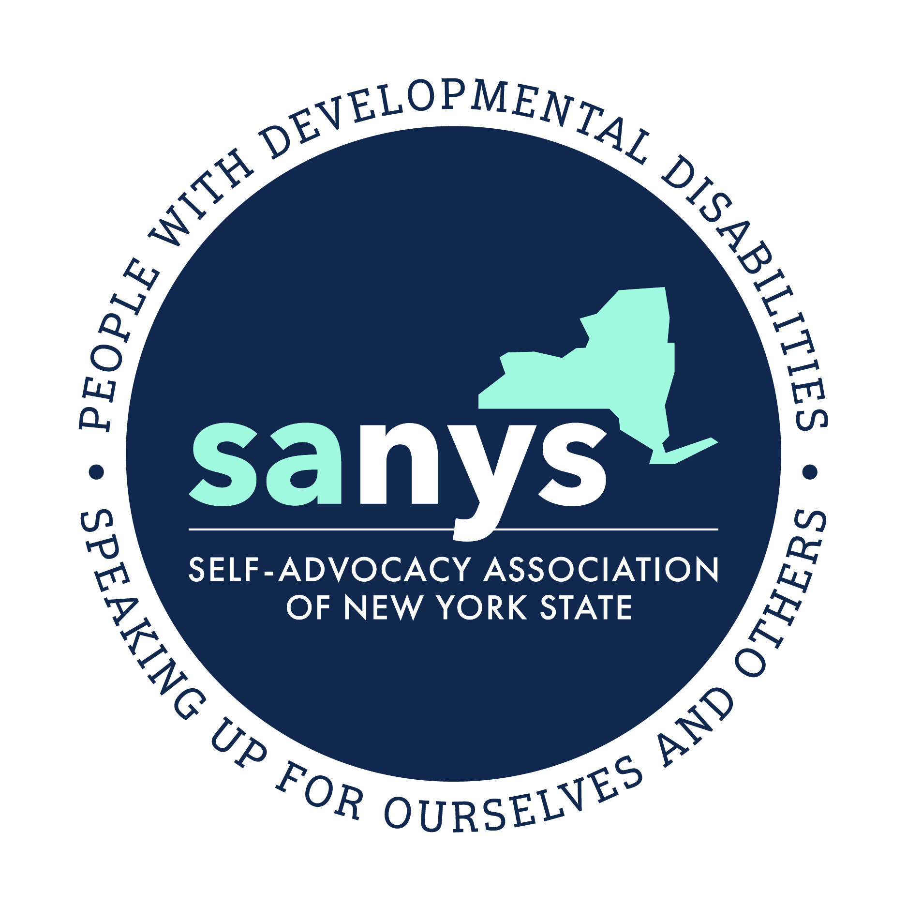

Self-Advocacy Association of New York State
2019 Position Paper

“We Rise with our Communities”

New York State is made up of communities of people who, while diverse, share many similar wants and needs. All people want to live in communities of their choice and achieve their full potential. New York’s citizens with developmental disabilities are just one of the many groups of citizens affected by decisions made by legislators and the New York State government.

New York’s citizens with developmental disabilities have always sought to have meaningful roles within their communities. However, barriers within the traditional service system and communities in general often get in the way.

While It is true that people with developmental disabilities continue to require innovative and person-centered services, it is equally true that they need many of the same things that other New Yorkers need. Access to affordable housing is necessary for people with developmental disabilities, as well as their neighbors. Transportation systems must work for people with disabilities, as well as the wider regions that they serve. Meaningful employment, as well as meaningful opportunities for employment, are particularly important to New Yorker’s with developmental disabilities, and we recognize good work at a living wage is essential for strong communities for everyone.

We ask that NYS recognize that supporting good lives for people with developmental disabilities is closely linked with creating and supporting inclusive communities that meet the diverse needs of all citizens.

TALKING POINT: We are people with developmental disabilities, but we are also citizens and constituents who share wants and needs with our communities and neighbors.

Housing
Housing must be affordable and inclusive:
Just like many other citizens in NYS, people with developmental disabilities are often held back from achieving their dreams and maximizing their independence and contributions to their community because of the prohibitive cost of housing. We advocate alongside members of our communities across NYS who must have access to housing which they can afford. Housing must be affordable for all, not just for some.

Lack of affordable housing can lead to poor health outcomes and increased care costs overall. Investments in affordable housing lead to desirable outcomes for New York’s citizens and the communities they reside in.

While NYS continues to invest heavily in traditional services and certified group homes that are needed by some, it is equally important to invest in more independent and innovative services and housing opportunities.

TALKING POINT: We deserve support for affordable housing, just like everyone else. Our housing must also support our independence and choice.

Employment and Daytime Activities and Supports
As with many citizens of New York State, a significant and ongoing problem for New York’s citizens with developmental disabilities has been lack of options and choices for meaningful days, with many continuing to be underemployed.
Day programs, similar to group homes, may be appropriate for some but are not the best option for most. We ask that legislators and NYS personnel continue to aggressively support solutions and funding for these problems, including support for community-based employment, volunteering, continuing and post-secondary education, community and day habilitation, Benefits Education and Advisement that incentivize work, self-directed employment options, supports for job development, and promotion of initiatives that create jobs for people with developmental disabilities, including tax incentives and affirmative action projects.
We strongly believe employment should be meaningful, chosen by the person, and deliver at a living wage.

TALKING POINTS: We want meaningful employment and options that we choose ourselves. The state and state agencies must support our employment and choice across all programs and services.

Self Determination and Self-Directed Services
Self-Directed Services are significantly less available in some regions of the state than others. Rural regions tend to have less opportunity where there is often a shortage of brokers and fiscal intermediaries.
For those already in self-direction, there continues to be a lack of clarity and consistency of practices across areas of the state. Self-advocates often feel that such confusion and inconsistency get in the way of their ability to truly direct their own lives.
For people receiving self-directed services it is crucial that self-direction retain its flexibility and freedom as NYS transitions to a managed care model.

Enhanced support for people in self-direction to help them navigate the housing and employment market is important as well if self-direction is to meet its promise of being a vehicle for New York’s citizens with disabilities to choose the direction of their own lives.

TALKING POINT: We want to preserve the philosophy and intent of self-determination.

Support Workforce: Be Fair to Direct Care
As a member organization of the #bfair2direct care coalition SANYS is grateful to the legislature and Governor Cuomo for the investment in direct support professional wages that is occurring this fiscal year.
High staff vacancy and turnover rates mean that people are not getting the lives that they deserve. In this situation people experience a limitation in choice, and face risks to their dignity, safety and well-being.
This is a crisis that must be solved on behalf of New Yorkers with developmental disabilities and the Direct Support Professionals that advocate alongside them every day, as a way to preserve the right-to-choice in our system

We ask the budget to include a Cost of Living Adjustment to support our workforce.

TALKING POINT: Support the #bfair2directcare campaign and bring back the Cost of Living Adjustment (COLA) for Direct Support Professionals.

Transportation
Transportation continues to be a significant area of need for New Yorkers with disabilities. Paratransit is still not available for many people within their communities, or availability is limited. People in rural areas suffer greatly from a lack of public transportation options. We ask that NYS take this problem seriously. We know that there is no easy solution. However, what is clear is that it merits immediate attention.
Accessible and affordable transportation needs to be a central consideration of all development and community planning. It is also important that investment in new certified homes for people with disabilities require sustainable transportation plans. Too often, people are finding their access to employment, and the community-at-large, limited.
To ensure adequate transportation services, public planning should include people with disabilities in the planning stages, by active invitation and by being held in locations that are accessible via para transit or other means available to people with disabilities. We would like to see New York explore innovative solutions both in urban and rural areas such as funds for paying a neighbor, or ridesharing projects.

TALKING POINT: Fund and support accessible transportation in all communities. A lack of transportation options increases costs and problems with all other systems.

Managed Care
As our system of supports and services transitions in the direction of managed care, self-advocates want to be included at the center of the planning process.
Self-advocates have great concerns over systems of care being managed or coordinated by outside or for-profit entities, as they do not have proven relationships with people with developmental disabilities and their families.
Above all, self-advocates want planning processes and budget decisions to be transparent and inclusive. People with developmental disabilities must understand the changes to their system and have the opportunity for meaningful and ongoing input before they occur. Clear and timely information must be provided to people for them to be able to make informed decisions. There must be a clear process for challenging or appealing decisions that a person disagrees with.

TALKING POINTS: We believe in robust and transparent communication. We need to be involved!

Cuts to Services:
Potential changes to state or federal funding for health care is of great concern to people with developmental disabilities across the state. The currently proposed cuts to the Consumer Directed Personal Assistance Program (CDPAP) are of deep concern to us as any service that creates better opportunities for New York’s Citizens with disabilities to live in their communities must not only remain but should be strengthened.
While we know that this is a federal issue, we would also urge our New York State representatives to commit to fully funding our system of services and supports through OPWDD as well as other state healthcare systems.

TALKING POINTS: Cuts to Medicaid will hurt all New Yorkers if the state doesn’t support us. Services like CDPAP must be strengthened, not cut or eliminated.

Guardianship & Supported Decision Making
We believe current law makes it too easy to impose guardianship on a person who doesn't need it, and it is currently too difficult to restore rights to people under inappropriate guardianships.
We support legislation that recognizes people's strengths and includes Supported Decision-Making plan certification where New York State would recognize solutions that a person develops within their own Circle of Support.

We invite you to meet your constituents in their communities:
We, the Self-Advocacy Association of New York State, ask that you consider today’s meeting as the beginning of a dialogue with self-advocates for the upcoming year. Our organization supports self-advocates across New York State and wants to facilitate visits to programs and communities where the voices of people with developmental disabilities can be heard directly. Please reach out to us to help support some of these critical opportunities for engagement with citizens in your districts.

TALKING POINTS: Visit us in our communities.

Disability Awareness:
Too often, people with developmental disabilities are marginalized within their own communities. New York’s citizens with Developmental Disabilities would benefit greatly from NYS investing in a statewide Developmental Disabilities awareness campaign focused on recognizing New York’s Citizens with Developmental Disabilities as valued members of their communities.

TALKING POINTS: People with developmental disabilities need to be seen as valued members of their communities. We need you to help to raise awareness in communities across New York State.

About SANYS

SANYS is an organization founded by people with Developmental Disabilities for people with Developmental Disabilities. We have been “Speaking Up for Ourselves and Others” for over 30 years.

The above statements represent views of the Board of Directors and Members of the SANYS. For more information, or to schedule a meeting or visit, please contact: Arnold Ackerley, Administrative Director at aackerley@sanys.org or 518-603-6706.

