Self-Advocacy Association of New York State 518-382-1454
500 Balltown Rd., Bldg. 12C, Schenectady, NY 12304 www.sanys.org

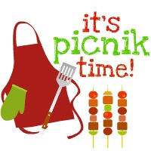
Self-Advocacy of New York State
Lower Hudson Valley SA PICNIC
Winding Hills Park
2 Old Rte. 17K, Montgomery, NY
Thursday, July 11, 2019
10AM – 2:00PM

Picnic in the Park: Come and enjoy group discussions, food, fun activities, vendors, etc.
Food includes: hamburger, kosher hot dog, veggie burger, black beans, corn salad and, potato salad, baked beans, potato chips, rolls, beverage & dessert.
Cost: ____$15.00 with lunch ____ $5.00 without lunch

Registration Information: (please register by July 5, 2019)
Name:____________________________________________________________________________
Address:______________________________________________________________________________
City:_______________________________ Zip:__________ Phone:__________________________
Hamburger:__________ Veggie Burger: ______________ Hot Dog: ______

