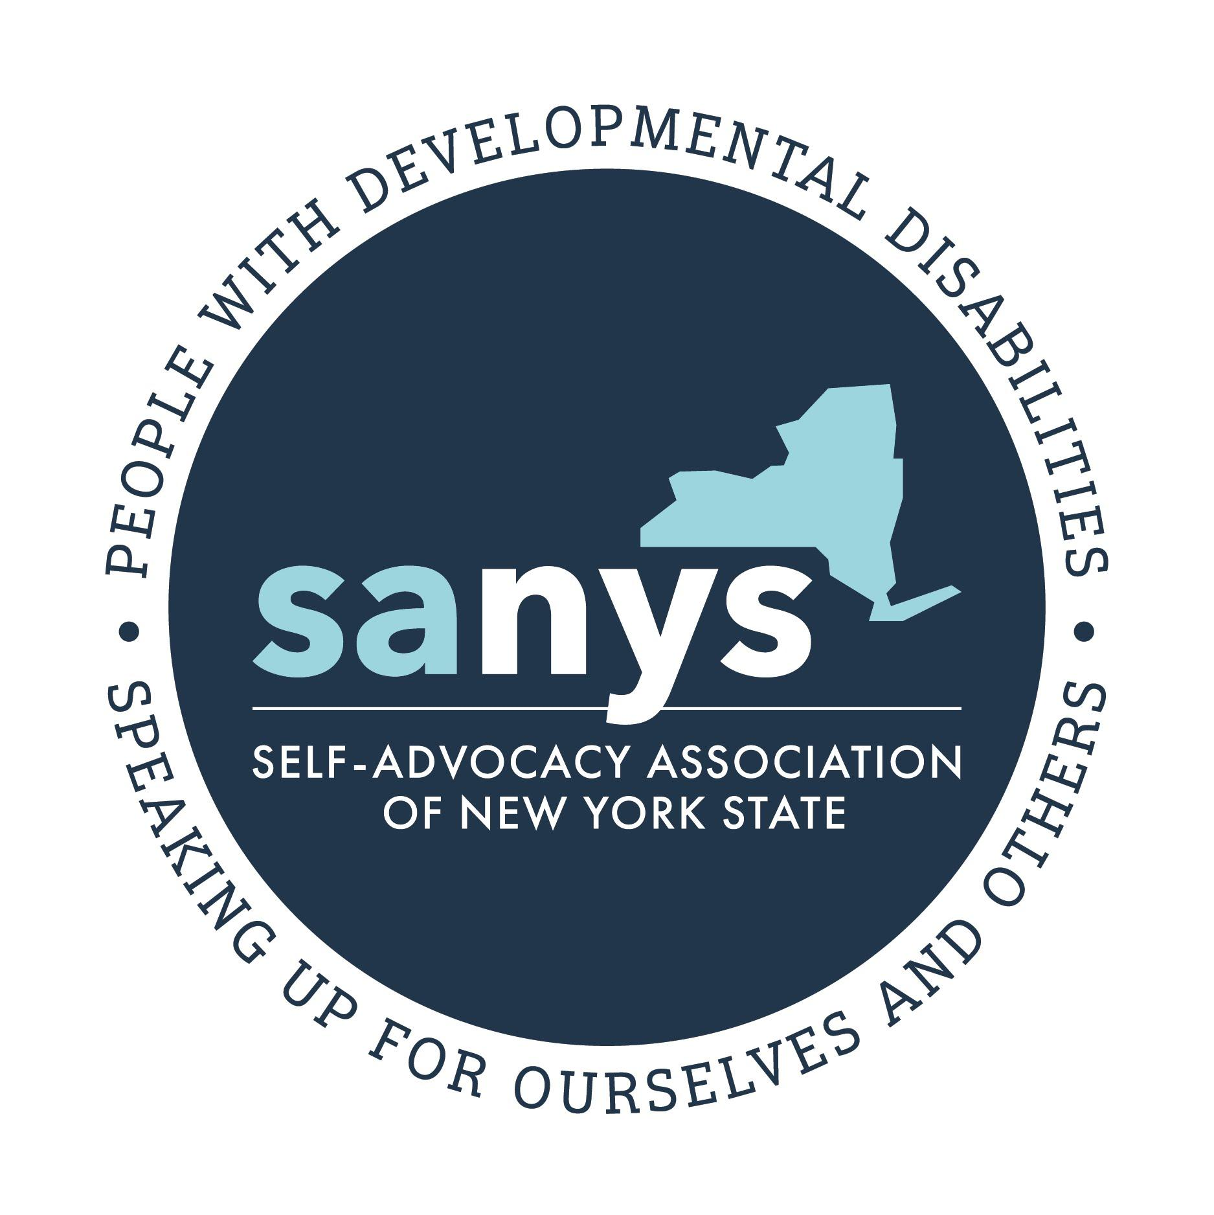
Self-Advocacy Association of New York State
2020 Position Paper

Stepping Up and Never Stepping Back

There has been much ongoing change in service design for New York’s Citizens with Developmental Disabilities in recent years. At the same time more changes and new challenges are on the horizon. Self-advocates across the state are concerned that, for the first time in decades, changes in the system may cause backward rather than forward steps in people’s lives.

We ask decision makers themselves to recognize that the system needs to continue to move forward despite current challenges. Together, let’s keep New York on track. Let us be a leader in innovative and person centered supports and services. Together let’s make sure that we are “Stepping Up and Never Stepping Back”.

Medicaid Redesign Team
As with all things, SANYS believes that all decisions about services and supports should involve people with disabilities who know themselves best. It is our hope that the work of the Medicaid Redesign Team will center the voices of people with disabilities and other representatives of diverse communities.

It is also our hope that any restructuring to Medicaid that may occur would be done with knowledge of the success of long term supports and services in the community in keeping people out of institutional settings.

TALKING POINT: People with disabilities want to be involved in planning about their own lives

Housing
Just like many other citizens in NYS, people with developmental disabilities are often held back from achieving their dreams and maximizing their independence and contributions to their community because of the prohibitive cost of housing. People with disabilities success depends on housing being affordable for all, not just for some.
While NYS continues to invest heavily in traditional services and certified group homes that are needed by some, people with disabilities want others to know about the importance of more independent and innovative services and housing opportunities.

TALKING POINT: People with disabilities benefit from housing that is affordable and supports their independence

Employment and Daytime Activities and Supports
As with many citizens of New York State, a significant and ongoing worry for New York’s citizens with developmental disabilities has been lack of options and choices for meaningful days.

Day programs, similar to group homes, may be appropriate for some but are not felt to be the best option for most. People with disabilities have benefited from support for community-based employment, volunteering, continuing and post-secondary education, community and day habilitation, Benefits Education and Advisement that incentivize work, self-directed employment options, supports for job development, and promotion of initiatives that create jobs for people with developmental disabilities, including tax incentives and affirmative action projects.

People with disabilities have also faced discrimination in employment opportunities through a lack of acknowledgement of IEP diplomas and other alternative certifications. We believe discrimination of this sort is wrong.

TALKING POINTS: We want meaningful employment and options that we choose ourselves.

Self Determination and Self-Directed Services
For people receiving self-directed services there is a great desire that self-direction retains its flexibility and freedom as NYS transitions to a managed care model.

Self-advocates using self-direction have achieved significant cost savings for the state compared to traditional services such as group-homes or day programs and have opened up opportunities in more intensive programs for people who truly need and want them.

Medicaid cuts that reduce support for robust self-directed services worry people with disabilities who may risk being forced into more costly institutional services or rolling back gains people have made in being part of their communities. People with disabilities worry about threats to their right to be in the “most integrated setting” if self-directed services were to fail.

TALKING POINT: We want to preserve the philosophy and intent of self-determination.

3 for 5 Campaign
We support the 3for 5 campaign. Despite an increasing need for these services, the Governor’s executive budget does not include funding necessary for the financial health of human services providers and the millions of people they serve.
More than 40 organizations representing thousands of providers across New York are joining together to ask the Governor and legislature to commit to a three percent increase across rates and contracts each year for the next five years, which is in line with the Governor’s statement that a 3 percent growth rate is projected and reasonable for Medicaid and education. Human services should be included in that projection, and this 3for5 investment is crucial to shoring up lifesaving services in New York.

TALKING POINT: People with disabilities agree that a 3% increase in funding for 5 years is needed to maintain supports and services

Transportation
Transportation continues to be a significant area of advocacy for New Yorkers with disabilities. Paratransit is still not available for many people within their communities, or availability is limited. People in rural areas suffer greatly from a lack of public transportation options. People with disabilities want to feel like transportation is being taken seriously.

People with disabilities benefit when accessible and affordable transportation is a central consideration of all development and community planning. Too often, people are finding their access to employment, and the community-at-large, limited.

To ensure adequate transportation services, people with disabilities want to be included in all of the planning stages, both by active invitation and by events being held in locations that are accessible via paratransit or other means available to people with disabilities.

TALKING POINT: We believe a lack of transportation options increases costs and problems with all other systems.

Managed Care
At SANYS we have seen the approaching transition to managed care as an opportunity to help
shape positive changes in the service system.

While we have taken a patient and collaborative approach to date, we find ourselves concerned
that no one has yet convinced us that managed care will work for Long Term Supports and
Services in NYS. We have growing concerns that managed care will take money from services, we are concerned about the lack of a clear plan for how self-direction will work under managed care, and overall the rushed pace of transition to date has already left many people confused.

If Managed Care is to move forward and be successful, many people with disabilities believe that a slower, more inclusive and strategic transition process would be more effective.

TALKING POINT: We wish that the process of implementing Managed Care would be a slower and more inclusive process

CDPAP
Similarly, to self-direction, the Consumer Directed Personal Assistance Program has allowed people with disabilities to achieve their right to live in the most integrated setting in their community, while avoiding the high cost to the state of institutional services.

Cuts to CDPA rates, while directed at Fiscal Intermediaries, concern those who are already struggling to pay their staff and worry many of risks of a return to more costly and restrictive services and supports.

TALKING POINTS: People with disabilities depend on CDPA to stay out of more costly and restrictive service settings

We invite you to meet your constituents in their communities:
We, the Self-Advocacy Association of New York State, ask that you consider today’s meeting as the beginning of a dialogue with self-advocates for the upcoming year. Our organization supports self-advocates across New York State and wants to facilitate visits to programs and communities where the voices of people with developmental disabilities can be heard directly. Please reach out to us to help support some of these critical opportunities for engagement with citizens in your districts.

Self-Advocates are excited about overcoming barriers they may face to participating in the democratic process and voting, and SANYS will spend 2020 engaging with our members and partners to promote these activities. Contact with their elected representatives goes a long way to supporting people with disabilities in participating in government.

TALKING POINTS: Visit us in our communities.

Disability Awareness:
Too often, people with developmental disabilities are marginalized within their own communities. New York’s citizens with Developmental Disabilities would benefit greatly from NYS investing in a statewide Developmental Disabilities awareness campaign focused on recognizing New York’s Citizens with Developmental Disabilities as valued members of their communities. Such a campaign would benefit in particular from the inclusion of people with intellectual and developmental disabilities.

TALKING POINTS: People with developmental disabilities want to be seen as valued members of their communities.

About SANYS

SANYS is an organization founded by people with Developmental Disabilities for people with Developmental Disabilities. We have been “Speaking Up for Ourselves and Others” for over 30 years.

The above statements represent the views of the Board of Directors and Members of the SANYS. For more information, or to schedule a meeting or visit, please contact Arnold Ackerley, Administrative Director at aackerley@sanys.org or 518-603-6706.

Feel free to contact your regional coordinator for more information. A Directory of our regional offices can be found at SANYS.org.

