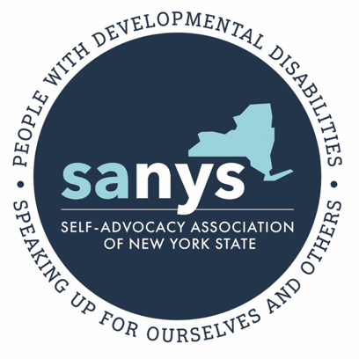

Recent events in our country has compelled us, SANYS, to examine and raise awareness of systemic racism and violence against African American people. The tragic death of George Floyd at the hands of police officers, has raised awareness about these ongoing issues.

We at SANYS are opposed to racism, discrimination and violence in all it’s forms. We believe that this is an important time to talk about racism. What happened to Mr. Floyd was wrong and it brings up many emotions and many questions about how change can happen. Many of us are deeply upset and concerned about these issues.

Self-advocates are not defined by their disability alone but as “whole people”. This is true of all citizens. Many things make up who we are, such as our religion, gender, sexual orientation, and yes, our race.

SANYS and Self-Advocacy is about using our differences to bring people and communities together, it’s about “Speaking up for ourselves and others”. We believe that our differences must be celebrated if we are ever to see an end to discrimination. Discrimination must become a part of our past if we are ever to have just and truly inclusive communities.

We would like to end by inviting each self-advocate to consider SANYS core values and the three questions below:

SANYS Values Statement

SANYS works toward positive social change while embracing the following values:
- HONESTY
- RESPECT
- INCLUSION
- CHOICE
- EQUALITY
- FREEDOM

What does each of these values say about racial discrimination? For example, are we honest about how race plays a role in our life and the life of our community?

How can we apply these values to the problem of racial discrimination?

Please join us on June 24th at 1pm Listening Forum on Race and Inclusion where a panel of SANYS Members will share their stories see the link below to join the meeting

https://us02web.zoom.us/j/88433136961 Call in: 1-929-205-6099 Meeting ID: 884 3313 6961

