SANYS Weekly Event Update 9/8/2020

And here’s what you might have missed last week of 8/31
Tuesday Wellness Series: Wellness Activity:
We created a Vision Board on Self Advocacy with Shameka
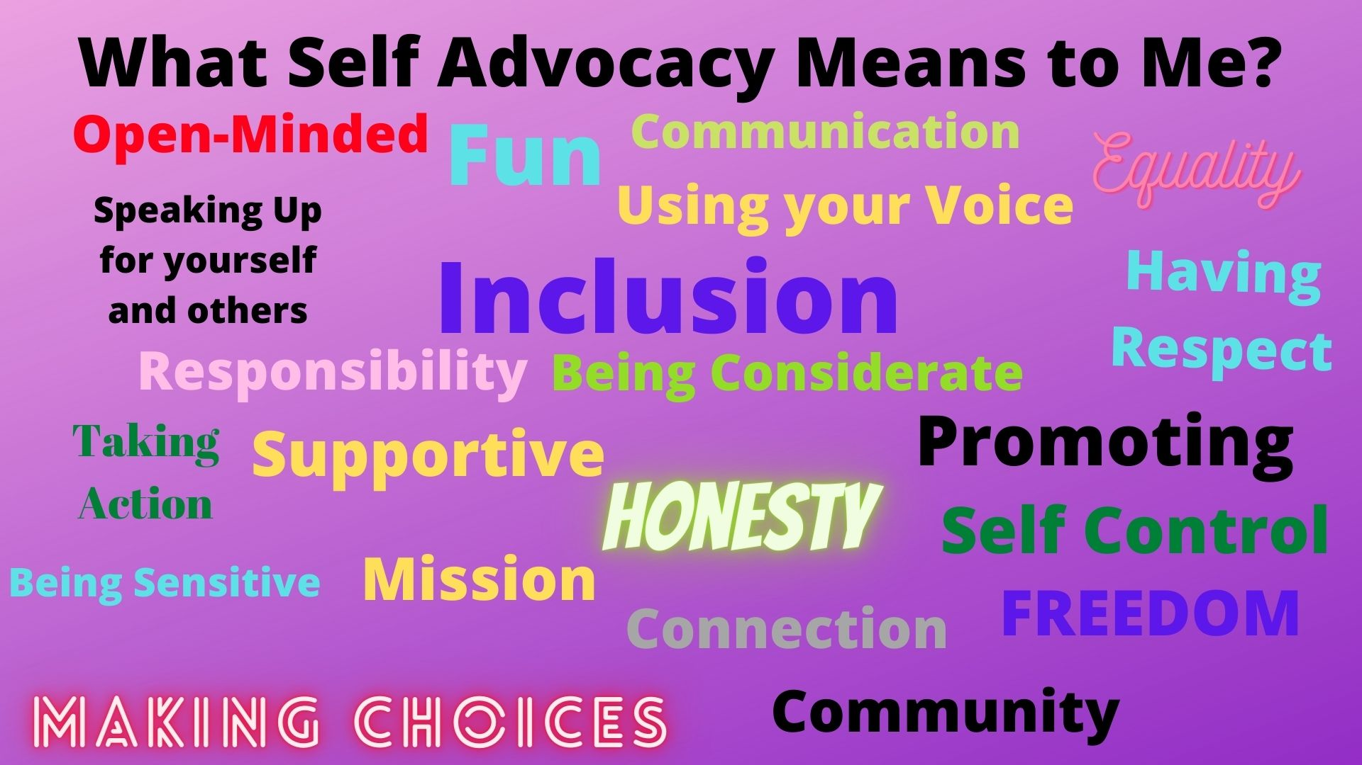
Wednesday’s Staying Connected:
Advocacy: We had an overview of the 20% Withhold
Video of 20% Withhold Easy Read being read- https://youtu.be/BB2JKv6idk0
Wellness quote of the week: “Choice is the mortar that binds together the things that make us who we are.” ― Fennel Hudson

Right of the Week with Marilyn Stata, OPWDD Rights Advocacy Liason

The opportunity to request an alternate living/work /day program setting.

It is your choice but with this also comes consequences when not followed properly. So with this being said you need to talk with your circle of support and include your care manager with your needs so that they are met to your satisfaction.
Wellness Activity: A Message from SANYS Member, Board Advisor and Minister, LaRenz Pickens
https://drive.google.com/file/d/1zaB63arsXrTpLRwNciNQmi6B1OY1Qdfc/view?usp=sharing
Friday’s “Staying Connected” Open Mic Support Group: Speaking UP
We read aloud an article about speaking up for ourselves even in tough times.
https://www.forbes.com/sites/andrewpulrang/2020/04/24/5-reasons-why-theres-no-wrong-time-to-fight-for-disability-rights/?fbclid=IwAR2sQJNnxto9Yspe-dLpbgT2LsVeP1n7XMFZ_gau4Ej4bnWizMnFc1uprec#5b493a13ac1c
Song suggested by Mike – Get Up, Stand UP by Bob Marley https://youtu.be/Tg97JiBn1kE
Song suggested by Sophia from Gwen- Brave by Sara Barielles
https://youtu.be/QUQsqBqxoR4

Here is what’s coming up this week, 8/31/20

Tuesday September 8th

4-5pm: Tuesday Wellness:
Topic: Tuesday Wellness Series - Right to Choice Vision Board activity with Renee Christian, Self-Advocacy Lead for Regional Centers for Workforce Transformation and Certified Life Coach

https://us02web.zoom.us/j/83725790129
Call In: 1-929-205-6099
Meeting ID: 837 2579 0129

Wednesday September 9th

1pm-3pm “Staying Connected” Advocacy-Wellness Zoom
Zoom Link: https://us02web.zoom.us/j/88433136961
Meeting ID: 884 3313 6961 Call in: 1-929-205-6099

Today’s Advocacy Wellness meeting:

Advocacy: Vote!- Registering and Ways to Vote

Wellness: Right of the week with Marilyn Stata, DDSO FL Rights Liaison, Quote of the week, Meditation with Shameka Andrews, Outreach Coordinator

4:30-5:30pm Tea Time hosted by People Inc.
https://us02web.zoom.us/j/7163227070
Meeting ID 716 322 7070
Password on request to rbanner@people-inc.org

Thursday September 10th

11am -12pm Communication is Key Chat Hosted by the Center for Self-Advocacy. Join Zoom Meeting
https://us02web.zoom.us/j/632063927
Meeting ID: 632 063 927
Password: 12344
One tap mobile
+16468769923,,632063927#,,,,0#,,12344# US (New York)

1pm-2pm SARTAC National Self-advocacy Call Join on computer, tablet or smart phone - https://zoom.us/j/324815633Or call 1-929-436-2866 and the Meeting ID: 324 815 633

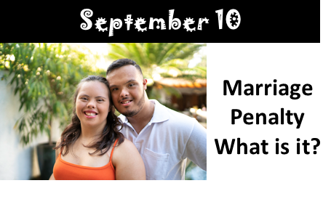
Friday September 11th

10-11am Coffee Hour hosted by People Inc.
https://us02web.zoom.us/j/7163227070
Meeting ID 716 322 7070
Password on request to rbanner@people-inc.org

1-3pm “Staying Connected” Open Mic Supportive Group
https://us02web.zoom.us/j/84144965654 Call in: 1-929-205-6099 Meeting ID: 841 4496 5654

4:30pm -5:30pm Happy Hour Friday hosted by People Inc.
Chat ID 716 322 7070
Password on request to rbanner@people-inc.org

Topic: Capital/Hudson Valley Region - DANCE PARTY
Time: Sep 11, 2020 6:30 PM Eastern Time (US and Canada)

If you have a favorite song that you'd like to hear, please email Shameka Andrews at sandrews@sanys.org. We will try to add as many as we can to the playlist.

Join Zoom Meeting
https://us02web.zoom.us/j/81306344518

Meeting ID: 813 0634 4518
One tap mobile
1-929-205-6099,81306344518# US (New York)

Saturday September 12th

1-2pm Saturday Chat with Gwen hosted by People Inc.
Chat ID 716 322 7070
Password on request to gsquire@people-inc.org

DJ Zoom Party, 7:30pm DJ Jammin Joe Saturday hosted by Joe Damiano
Dance Party https://zoom.us/j/98074946684

