Public Transit Websites
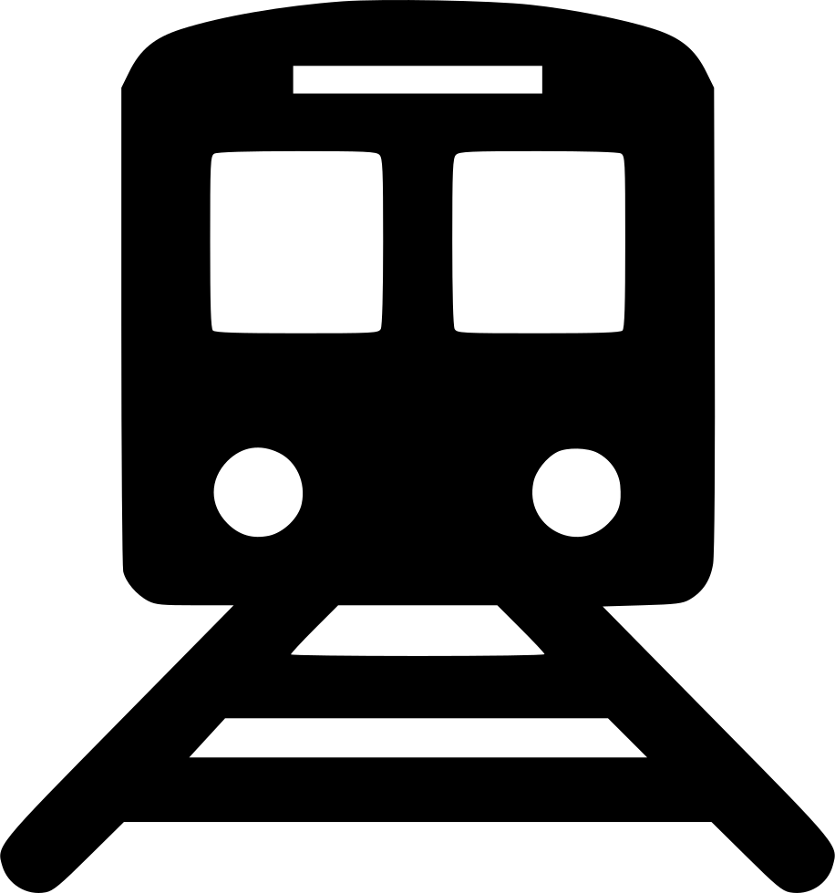

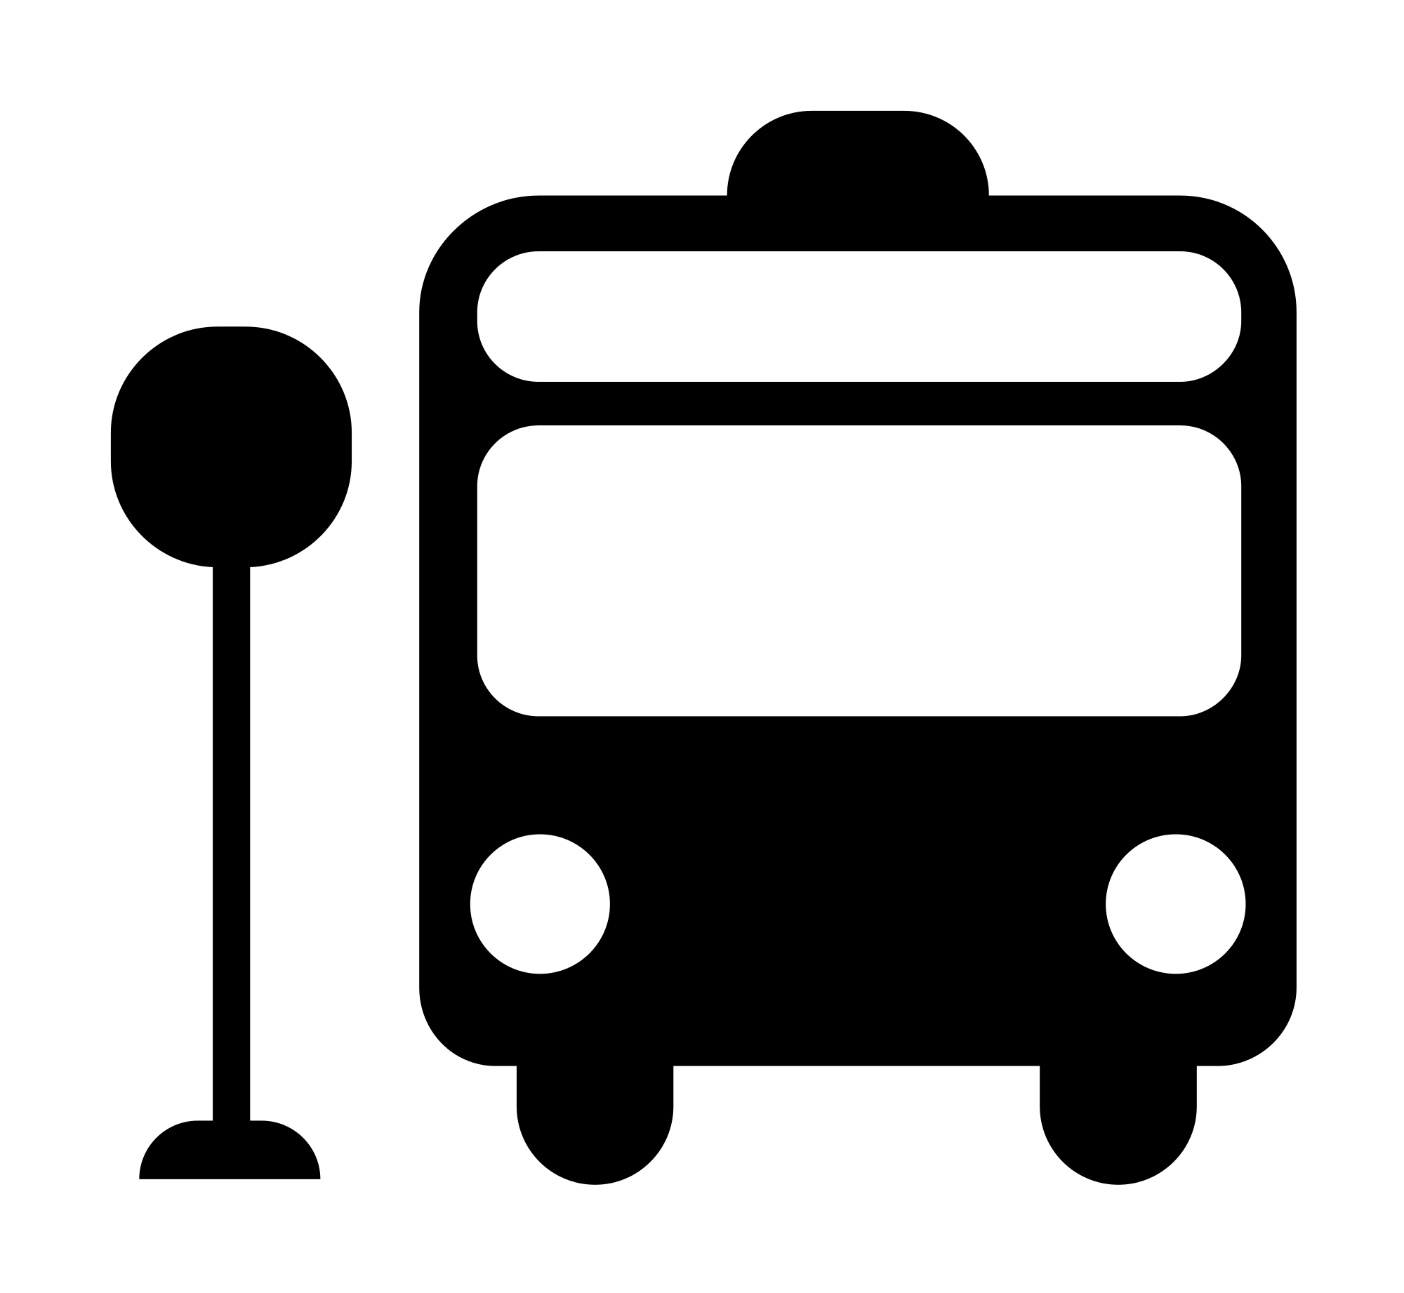

Region | Transportation Authority | Website
Long Island | Long Island Railroad (LIRR) | https://new.mta.info/
 | Suffolk County | https://suffolkbus.com
 | Nassau County | https://nicebus.com
NYC-Westchester | Metro North Railroad | https://new.mta.info/
 | NYC Subway / Bus Service | https://new.mta.info/
 | Westchester Bus Service | https://transportation.westchestergov.com
Lower Hudson Valley | Orange County (TO) | http://www.transitorange.info/bus-services/
 | Putnam County (PART) | https://www.putnamcountyny.com/transportation/
 | Rockland County (TOR) | http://rocklandgov.com/departments/public-transportation/transport-of-rockland/
 | Sullivan County (MOVE) | http://sullivanny.us/Departments/Transportation
Capital / Upper Hudson Valley | Capital District Bus Service | https://www.cdta.org/
 | Ulster County (UCAT) | https://ulstercountyny.gov/ucat/ulster-county-area-transit
 | Dutchess County (Loop Bus) | https://www.dutchessny.gov
 | Columbia County | https://www.johnstonbus.com
 | Greene County | http://greenecountytransit.com
Central | Tompkins County | https://tcatbus.com/
 | Gadabout Service | https://gadaboutbus.org/
Finger Lakes/ Rochester | Yates County | http://yatestransit.com/
 | Chemung County | https://ridectran.com
 | Steuben County | ridesteuben.com
 | Schuyler County | http://schuylercountytransit.org/
 | RTS | https://www.myrts.com
Western / Buffalo | Erie and Niagara Counties | https://www.nfta.com//
 | City of Olean (OATS) | https://www.cityofolean.org/commdev/oats/
 | Cattaraugus and Allegany  Counties (STS) | https://sni.org/STS
 | ACCESS Allegany | http://www.ardentnetwork.org/access-allegany-schedules.html

